# SYSTEM ARCHITECTURE

INTRODUCTION

6. Making all the functions more customizable, also there will

be broader range of sports covered

at the same

level of each individual

1. Compare fitness screen.
2. Generate graph based on specific games, which means a runner will get information which are related to running and a footballer will get information related to football sports.
3. Knowing athletic side with better opportunity and plan for a bright future.
4. Team fitness management.
5. Team collaboration

Fitness trackers are one popular way to keep track of progress and encouraging you to push your limits. In progress report. Our system can track your goals and with the help of regular exercise, a person can improve his or her health and fitness. The results of fitness information lead to the conclusion that the developed system can be used to significantly increase speed and improve quality with better collaboration. Our system will incorporate all the data together, and analyze them to bring out their strong side, so he can focus on that and develop on that more.

CONCLUSION

Sportsmanship is an aspiration that a sport or activity will be enjoyed for its own sake, with proper consideration for fairness, ethics, respect, and a sense of fellowship with one's competitors. The app makes one aware about your weak points and mistakes that he/she committed. Fitness trackers are one popular way to keep track of your progress. Depending on the tracker, wearers can track steps, calories, distance traveled, caloric intake, and even heart rate. It acquaints about the changes that are needed in your strategy. Instead of cursing yourself, it gives the chance to learn from another member of his/her team.

ABSTRACT

Dynamic Sportsman System provides the essential performance insights that every coach needs on individual athlete. It tracks and analyses training loads of athletes to guide him and provides proper nutrition advices. The app designed to help users time and plan their workouts based on either key exercises or by the area of their body that they want to target. With workouts and circuits adjusted based on the skill of the user. Rather than a solution to just lose weight this is an app that will raise their general fitness overall.

* Personal fitness management
* Capture and track even basics like height, weight
* Storingthe data ina database
* Progress reports to identify athletic strengths and weaknesses
* Daily ormonthly progress inagraph
* Retrievalinpersonal account

PROTOTYPE

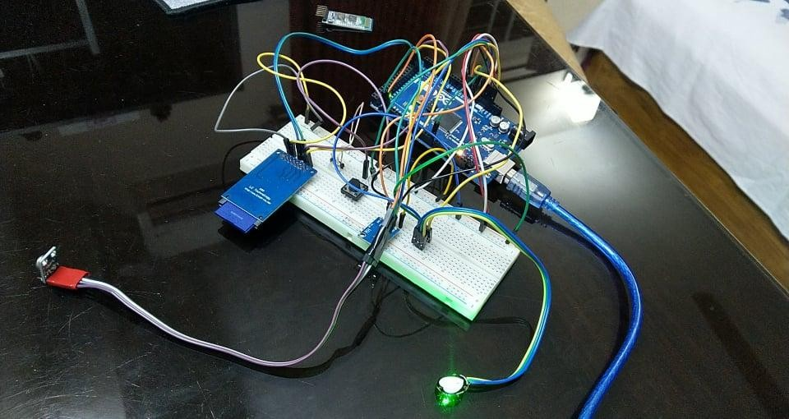

FUTURE WORK

WORK FLOW

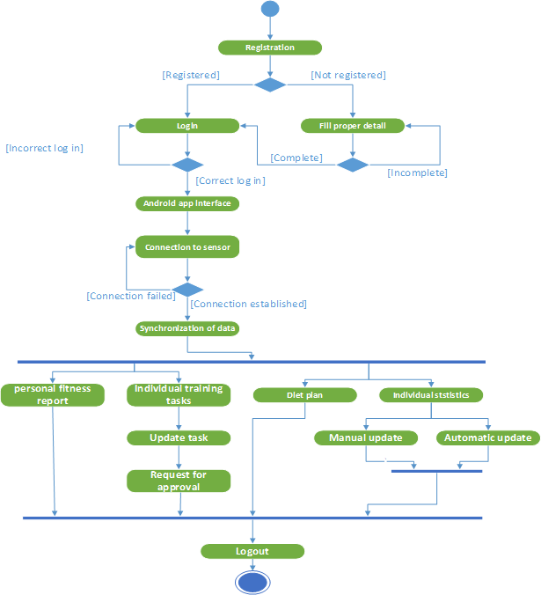

.



Dynamic Sportsman System (DSS)

Maj Tamzid, Maj Nafiz, Maj Shameem, Maj Rashid, Lt Abir, Lt Belal

Department of Computer Science and Engineering Military Institute of Science and Technology

COST ANALYSIS

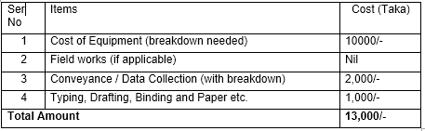

Table 1: Cost for prototype

1. Interview with Retired Major Imtiaz Elahi. Founder of BD RUNNERS (BDRUNNERS is the organization which organize DHAKA HALF MARATHON EVENTS).
2. Interview with Mr. Mahfuz(Boxing Coach,BKSP).
3. Interview with Dr. Zaman Sunny (Nutritionist,DMC).

REFERENCES

* The main objective of “Dynamic Sportsman System” is to develop personal fitness, analyzing data from different wearable sensors and creating game plan through documented statistics.
* To the team moderator to assign team/individual with specific training.
* To generate by the nutritionist with new diet charts.

0BJECTIVE

FEATURES